

**ASSIGNMENT 3 REPORT**

Name: MUHAMMAD AYAZ HASAN

Roll No: 20K-1044

Section: BS-SE (5A)

Subject: Software Construction & Development

Date of Submission: 27/11/2022

**Description Of Program**

The below Program is develop to solve the Complex Equation Science

Which used to Calculate the Gravitational Force

The formula is F=Gm1*m2/r sq.

**Multithreading using Runnable Interface**

* First we take the user input all the required values to solve the equation

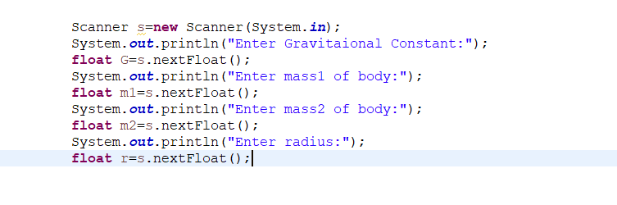

* Now we run 5 different thread in parallel to distribute the component of the equation

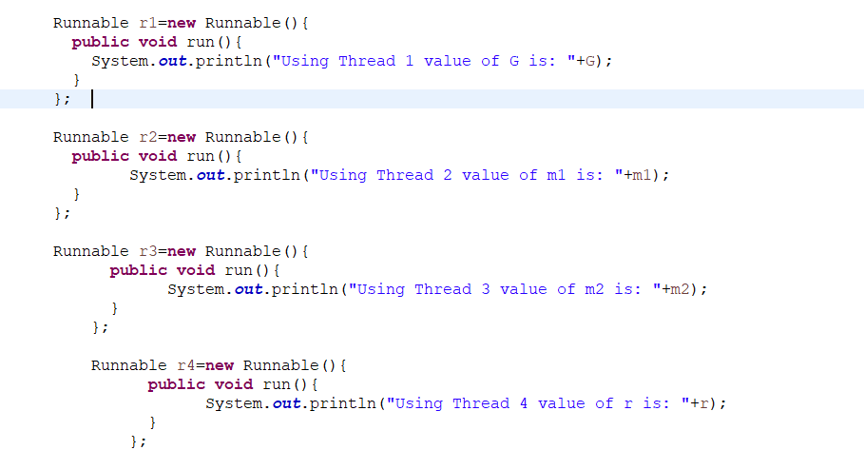

* Try and catch is used to maintain the Synchronization when thread are running

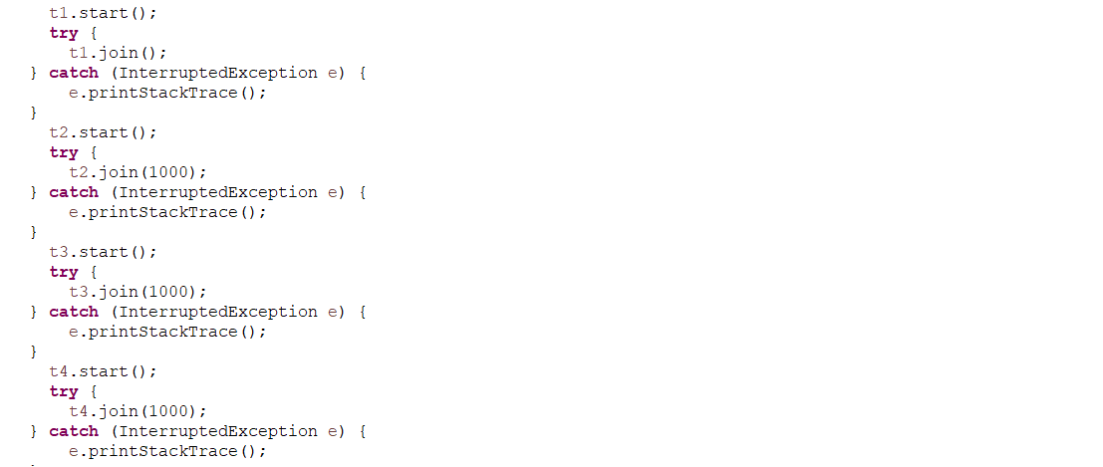

* The output is as follows



